Mount Lawley Primary School

PARK IT for the PLANET

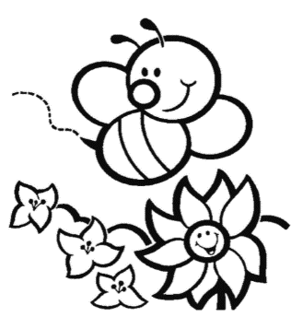

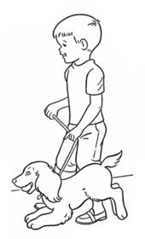

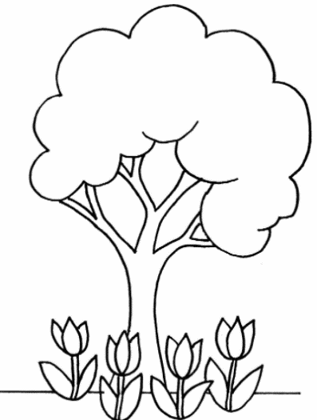

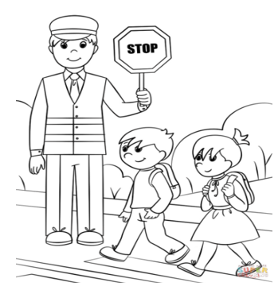
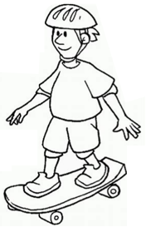

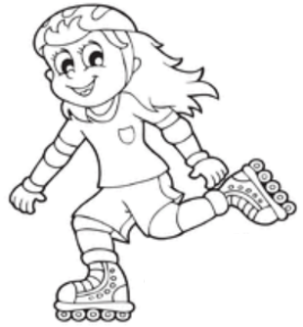

Walk, ride & scoot safely!

Name: ___________________
Year & Room Number: ______________________
Good sustainability message: ________________________________________

pedestrian street free colouring in - Bing images
Tree with flowers - trees free clipart colouring in - Bing images
Tree - trees free clipart colouring in - Bing images
bee -bees colouring in - Bing
bird - birds free colouring - Bing images
boy on bike - 1e42c19ff48402d4643cf8bdcabe4355.jpg (1000×1080) (pinimg.com)
boy on skate board - skateboard free colouring in picture - Bing images

Name : __________________ Sustainability message: ________________________________
Year: ____________________ ____________________________________________________

