## Sub headings (Arial Black 18)

Recommended general body text in Arial font size 12

TIP 1: You can just copy and paste these boxes to easily create new sections ready to type into

# Poster Title

**Dot point headings**

**The first few words of a dot point** can be bolded in blue.

* All dot points text in Arial 12
* You’ve probably noticed the dot points are in blue!

Lower level headings

**(Arial Bold 16)**

General body text in Arial size 12

TIP 2: Don’t worry about the faint background, when you print it, it will be in full colour.

Photos

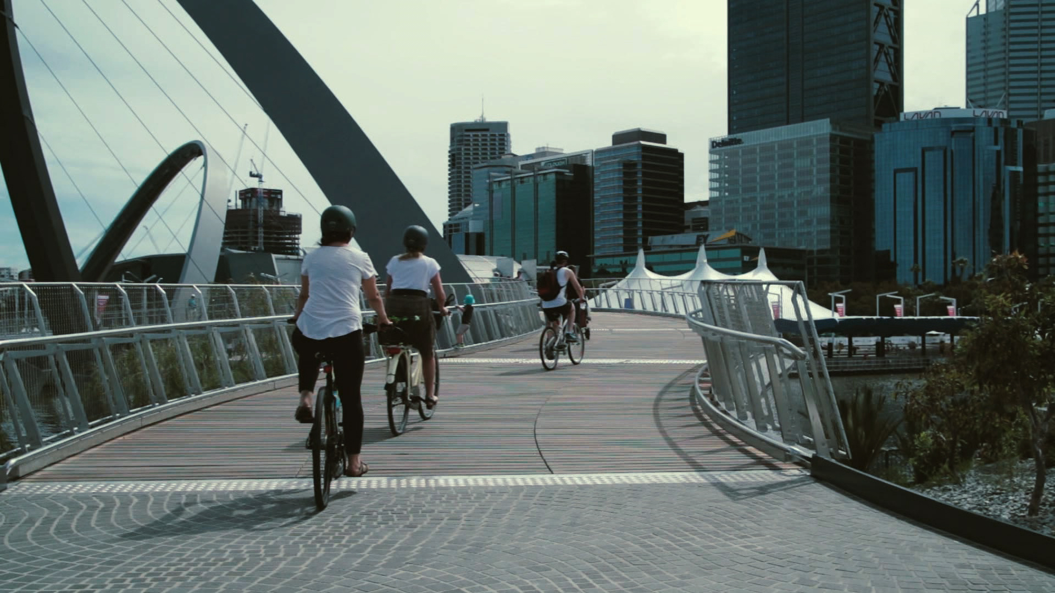 To use this nice rounded mirror effect, right click on this image and choose “Change Picture” Or highlight the photo you’ve inserted and select Picture tools – Format – Reflected Rounded Rectangle.

TIP 3: Resize images in the right proportions by holding Shift as you resize a corner.