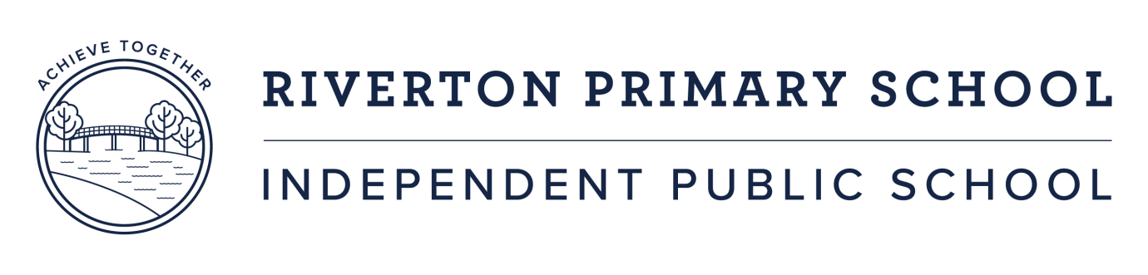

4th September 2020

Dear Parents,

Riverton Primary School has formed a partnership with the Department of Transport with a focus on reducing traffic around the school. The program called, “Your Move” aims to work with the school community through the students, in developing ways to minimise traffic around the school by encouraging more active methods of transport to and from school.

Your child is an active member of the Green Team, our sustainability program at school and has been selected, because of their enthusiasm and commitment to this program to assist in leading the “Your Move” program at Riverton Primary School.

Next Tuesday your child will be working with 7 other students from Riverton in Years 4 and 5, with Mrs Katherine Ellery, myself and a representative from the Department of Transport. The aim of this session is to begin to develop a plan for Riverton Primary School’s involvement in “Your Move”. We believe this is an exciting opportunity to make a sustainable positive impact on our school environment focusing on physical activity and safety around the school. This planning session will take place at the school from 9.30 am – 11.00 am.

If you have any questions regarding this program and your child’s involvement please do not hesitate to make contact with me directly at the school on 9237 2750 or by email: [lea-anne.frossos@education.wa.edu.au](mailto:lea-anne.frossos@education.wa.edu.au).

I look forward to working with your child and the positive impact we can have on our school community.

Yours sincerely

Lea-anne Frossos

Deputy Principal