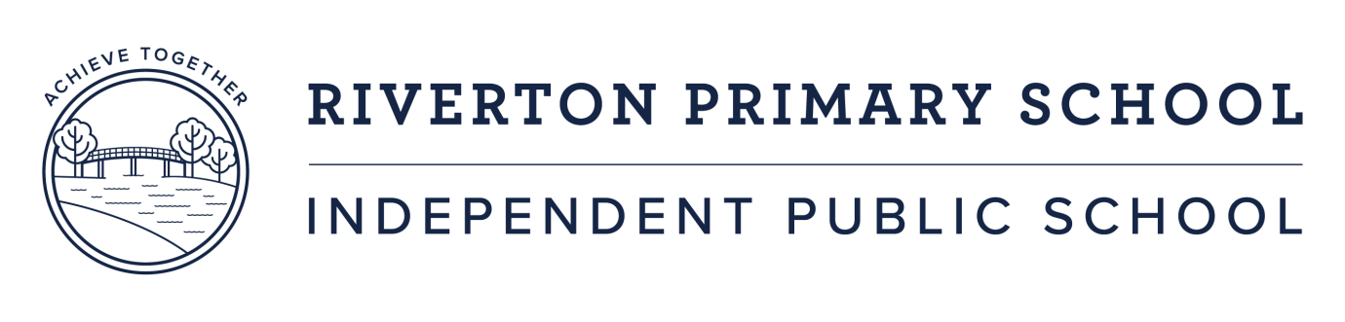

**Your Move Schools Initiative - 2020**

Through our liaison with the City of Canning and the Department of Education with regard to traffic management and flow around our school, we have been invited to participate in the Department of Transport’s “Your Move Schools” program.

Paul and Lea-anne met with a representative from the Department of Transport to discuss our involvement in the program and what this might look like for Riverton Primary Campus. Your Move Schools is a community-focused program that supports schools and students to use active and sustainable transport options to and from school more often (Champion Guide, page 1, 2020). Schools are supported with access to teaching resources, advice from consultants and access to funding and rewards as we embrace a more active approach on our way to and from school each day.

It is anticipated the program will be coordinated by Lea-anne Frossos, who will work collaboratively with Katherine Ellery and members of the Green Team in Years 4 and 5. The Green Team are a group of students who have an interest in environmental concerns and sustainability. There will be training involved for these students and we look forward to encouraging their leadership as they progress through the school.

Professional Learning is available to staff to support the development of the initiative, which in turn we believe will support increased student autonomy, responsibility and resilience. We are looking forward to this opportunity as we work to continue to support physical activity for students, leading to positive learning and mental health outcomes as well as reduced traffic congestion at school start and finish times.

Lea-anne Frossos

Deputy Principal

July 2020