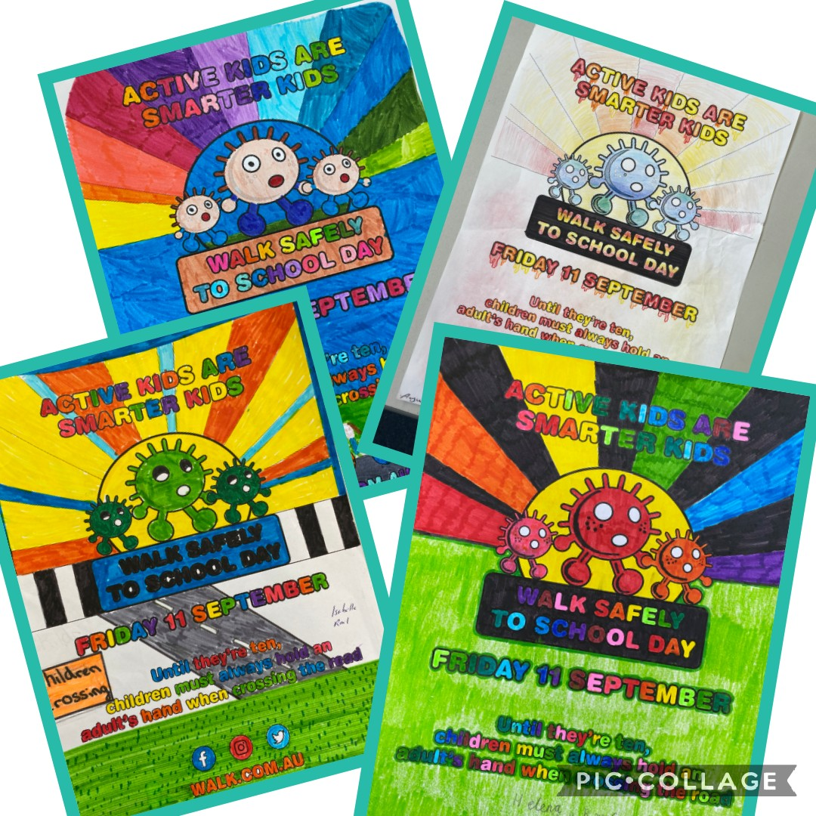

**Some of the fantastic colouring-in winners**

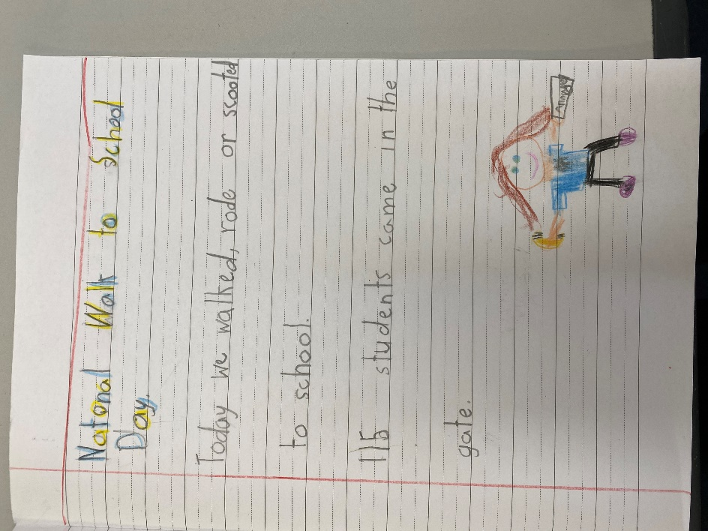

**Example of the year 1 writing lesson**

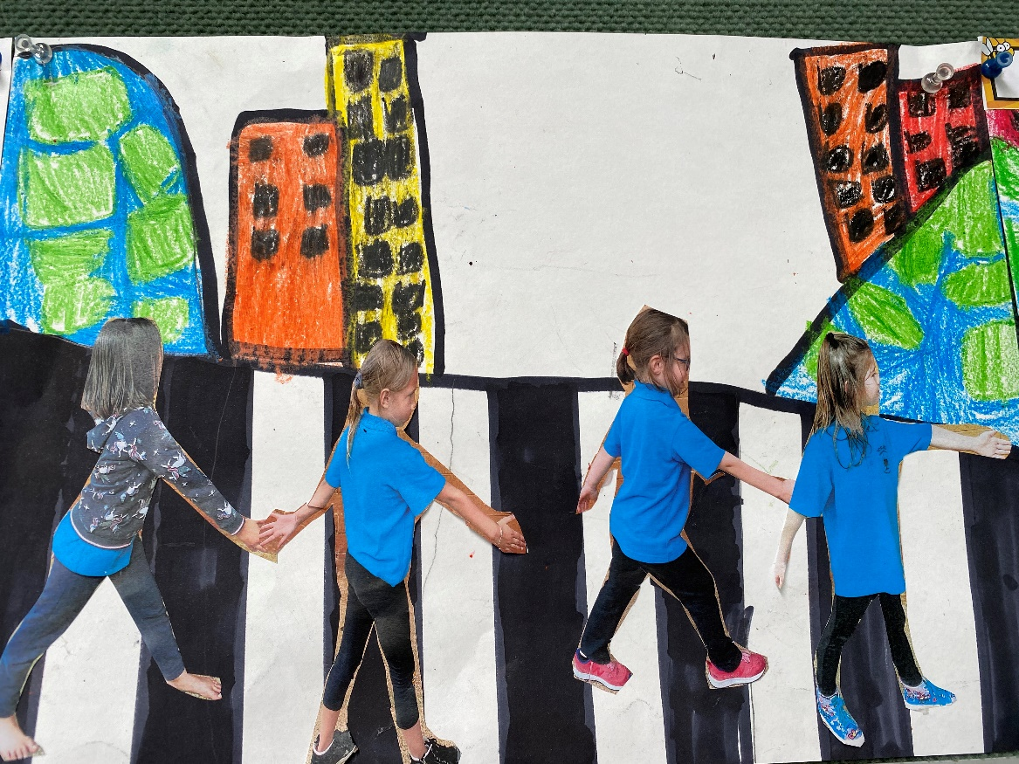

**Year 1 Art project**