Year 8 Data Investigation Assessment Task Total Marks / 30
Students at a Year 8 level can explain issues related to the collection of data and the effect of outliers on means and medians in that data. Students make sense of time duration in real applications.

Marking Key

- During the 2040 presentation you were asked to participate in a live poll to consult you about what is important in your future. Describe two advantages and two disadvantages of using a live poll to collect data. (4 marks)

One mark for each reasonable answer

Advantages
- Interactive and engaging, results are in real time
- Can collect large amounts of data in short period of time
- Can identify the audiences views, opinions or knowledge on a subject

Disadvantages
- Vulnerable to trolls
- Relies on connectivity to Internet – not everyone may connect

- In your own words describe what an IoT device is and provide an example of how it could be used to create a more sustainable future. (4 marks)

IoT device (Internet of Things) √ is a device that is connected to the internet and collects data or information in real time √ . An arduino is an IoT device that the students have used in their technology class.

It could be used to reduce energy by turning lights on and off when required or turn sprinkers on only when soil levels are dry to reduce the amount of water used in irrigation √√

- Active commuters who walk or cycle are usually less exposed to pollution than people travelling by car or bus – this might be because vehicles travel in a queue, so air pollution from the vehicle directly in front gets drawn in through ventilation systems and trapped inside. 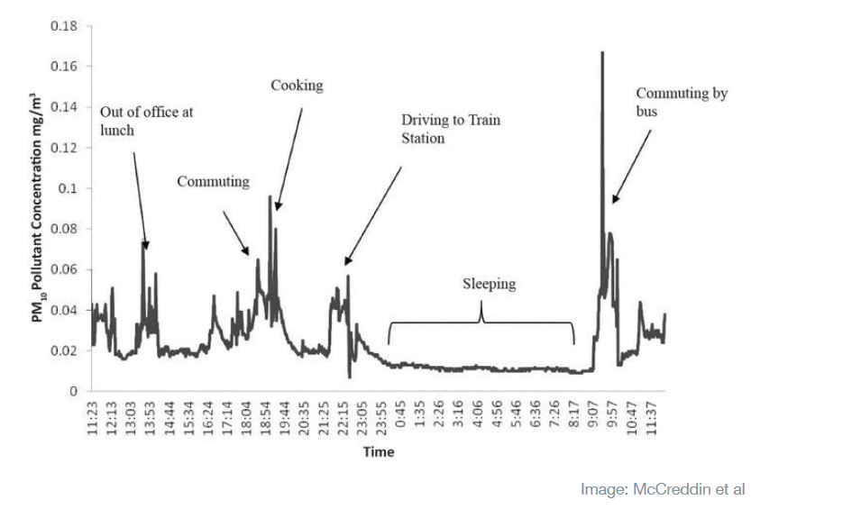Use the graph time series graph shown above to describe how a commuter’s exposure to air pollution changes at different times of day. (3 marks)

The graph show that exposure to pollutants peaked in the morning around 9.30 am while commuting by bus to work.

The least exposure is at night while they are sleeping between 11.30 pm and 8.00am .

There is a couple of other smaller spikes when they are out at lunch and during cooking a meal at 8pm.

To get the three marks students should describe the data and make sense of it as an application of time duration

- Improving outdoor air quality is currently a top priority in cities across Europe – and rightly so. But measurements and computer models are indicating that our exposure to pollution is much more varied and complex than currently estimated. Consider the practicalities and implications of collecting actual measurements of air pollution that we can trust. Would you trust your mobile phone to become a portable pollution sensor? Explain your reasoning, considering the practical implications of this type of data collection.
(4 marks)

Mobile phones are portable and readily available. √

Mobile phones would allow lots of data to be collected in real time √

Data would be personalised so you could make changes to your own life to reduce your personal exposure √

Security issues involving what other information could be collected from your phone

Who pays for the data service?

Any reasonable answers where students have thought critically about the question.

- During contact class, students participated in the Your Move for Schools survey. Was this a census or a sample? Justify your choice by briefly describing the difference between a sample and a census. (3 marks)

This survey was a census √ as all the students √who attended the school on the day attend a contact class and are surveyed. A sample would have been if a group of students were selected √ from the college to represent the whole school

- Using the data collected by the Smart City Project device, you are to investigate one of the pollutants collected. You will be required to use spreadsheet commands to calculate the means and medians of your chosen data set and the effect outliers have on the results.
Compare your results with the Australian National Air Quality Standards and write a one page report that discusses your findings. (12 marks)

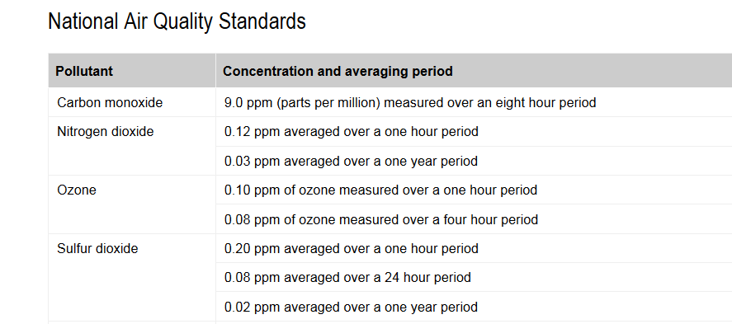

Introduction – 2 marks

Calculates mean and median using Excel commands 2 marks

Sorts data and looks for any extreme data values 2 marks

Takes a deeper dive into the data by calculating means and medians within specific time periods

2 marks

Compares the results of data analysis with National Air Quality Standards - 2 marks

Writes a conclusion based on the findings in the data analysis - 2 marks

